🔐 Cybersecurity Assessment Report
Target Application: OWASP Juice Shop
Security Assessment Report – Week 1
1️⃣ Introduction
This report presents the findings from a security assessment conducted on a mock web application, OWASP Juice Shop, as part of the Cybersecurity Internship Task (Week 1).
The objective was to:
- Analyze application functionality
- Identify common vulnerabilities
- Perform basic penetration testing
- Document findings and recommend improvements
The application was deployed locally using:
npm install
npm start
Accessed at: http://localhost:3000
2️⃣ Application Overview
The following features were tested:
- User Signup
- User Login
- Add to Cart
- Profile Management
- Input Fields Validation
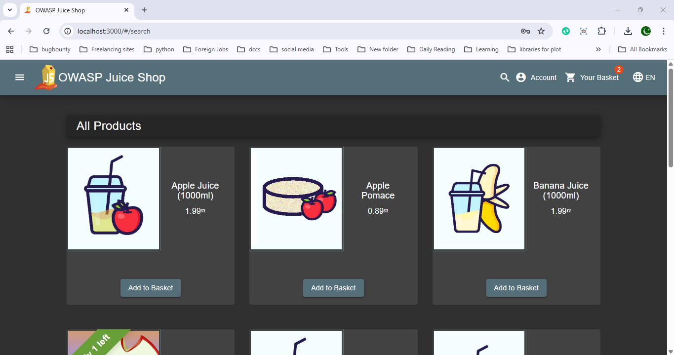

3️⃣ Security Testing & Findings
🔎 3.1 Password Policy Enforcement
Test Performed:
- Attempted signup using a weak password.
- Application denied weak password.
- After following password requirements, signup was successful.
Finding:
✔ The application enforces password complexity requirements.
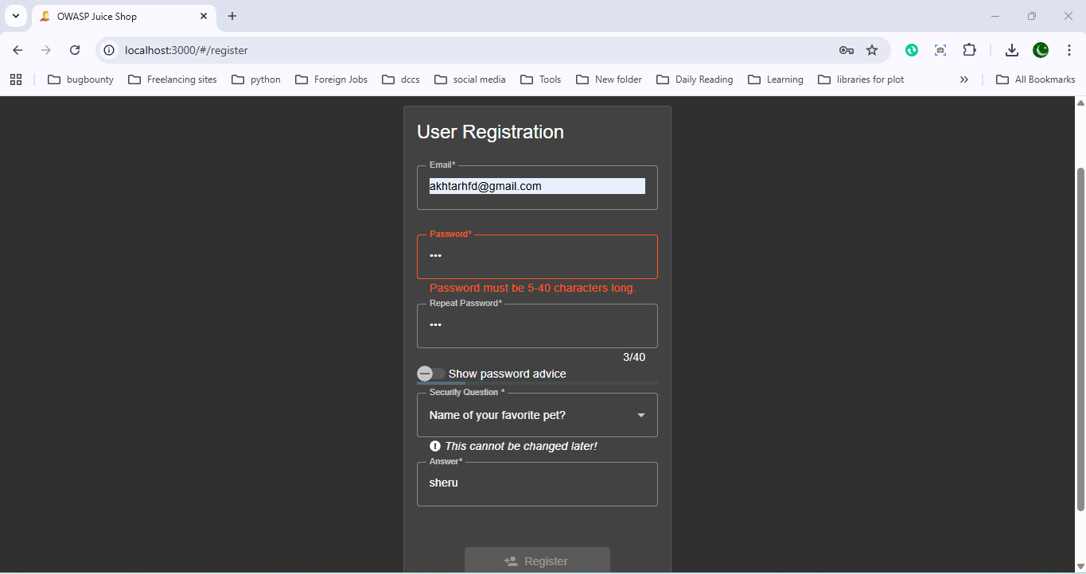

Security Level: Basic protection implemented.
🔎 3.2 Login Functionality Testing
- Successfully logged in using registered credentials.
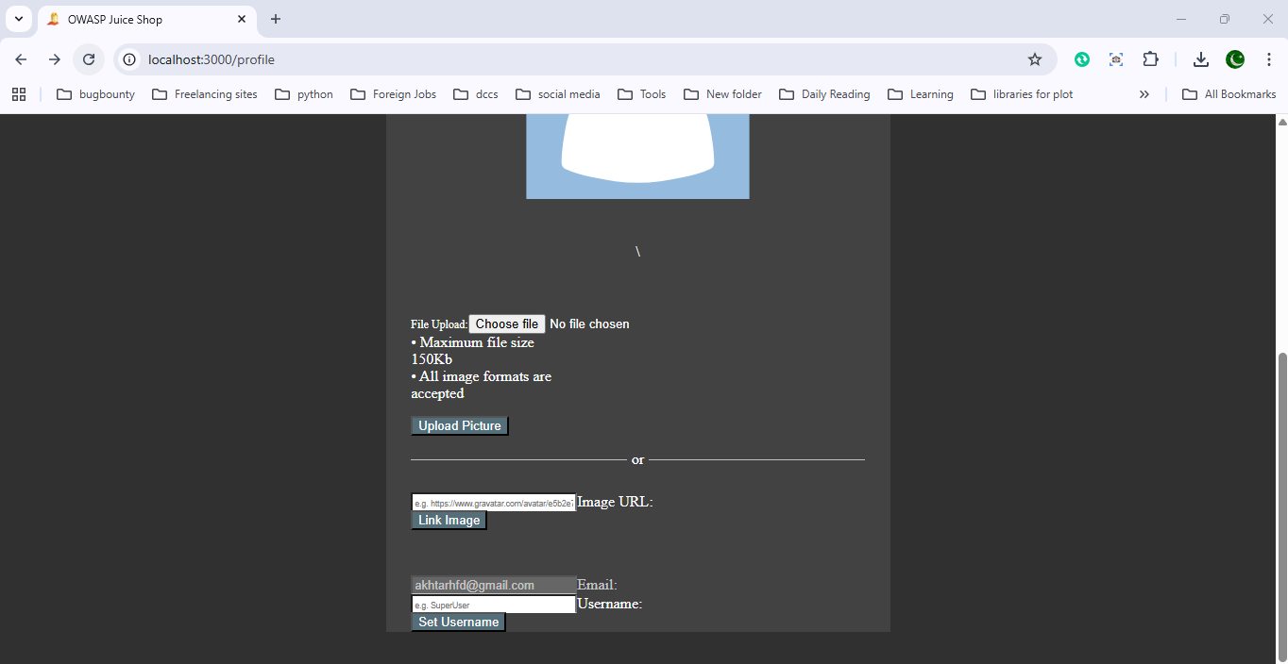
- Attempted login using:
  - Email: admin
  - Password: admin
Result:
❌ Login denied.
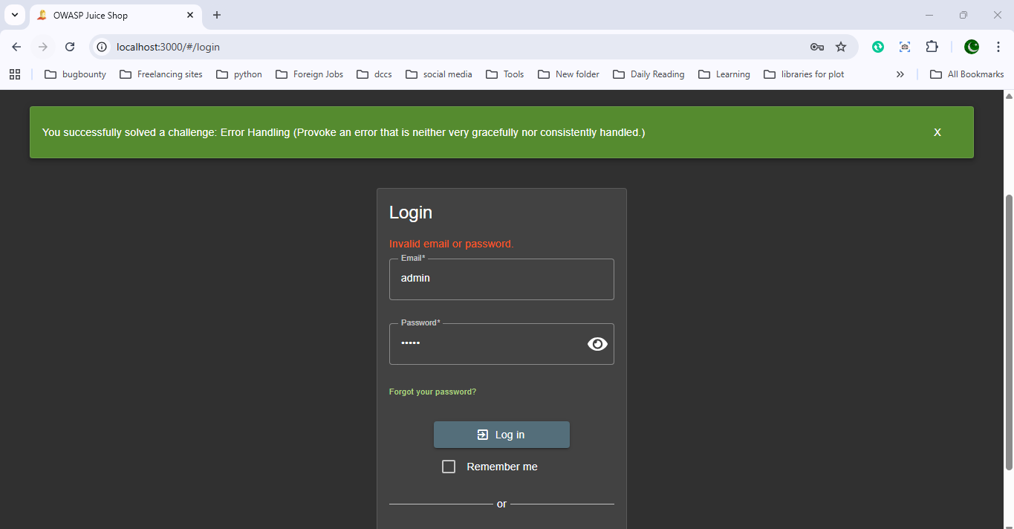

Finding:
Default credentials were not accepted directly.
🔎 3.3 Input Validation & Error Handling
Test Performed:
- Injected custom code into input fields.
- Triggered input validation classes.
- Application displayed message:
"You have successfully solved a challenge: Error handling – provoke an error that is neither very gracefully nor consistently handled."
Finding:
⚠ Error handling is inconsistent and exposes challenge information.
Risk:
- Improper error handling can leak internal logic.
- May expose stack traces or internal processing.
🔎 3.4 SQL Injection Testing
Test Payload Used:
Admin ' OR '1'='1
Used in both:
- Username field
- Password field
Result:
- Application triggered challenge success message.
- SQL Injection vulnerability successfully exploited.
Finding:
🚨 SQL Injection vulnerability exists.
Impact:
- Authentication bypass possible.
- Unauthorized access risk.
- Database compromise potential.

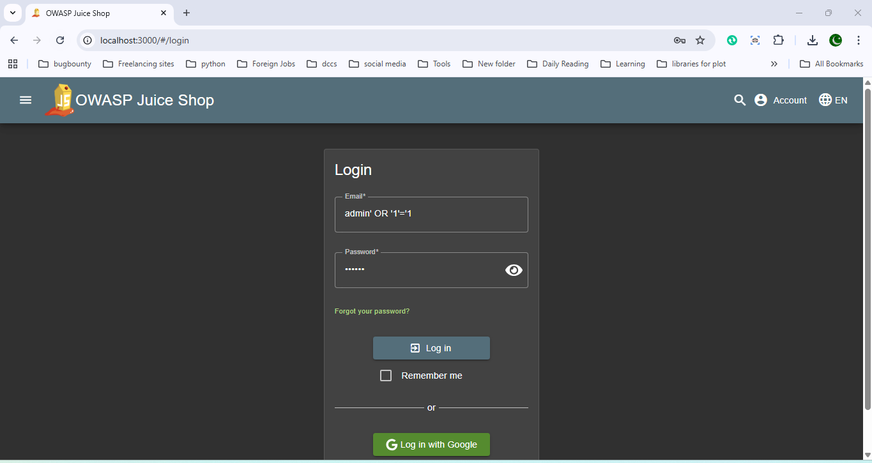
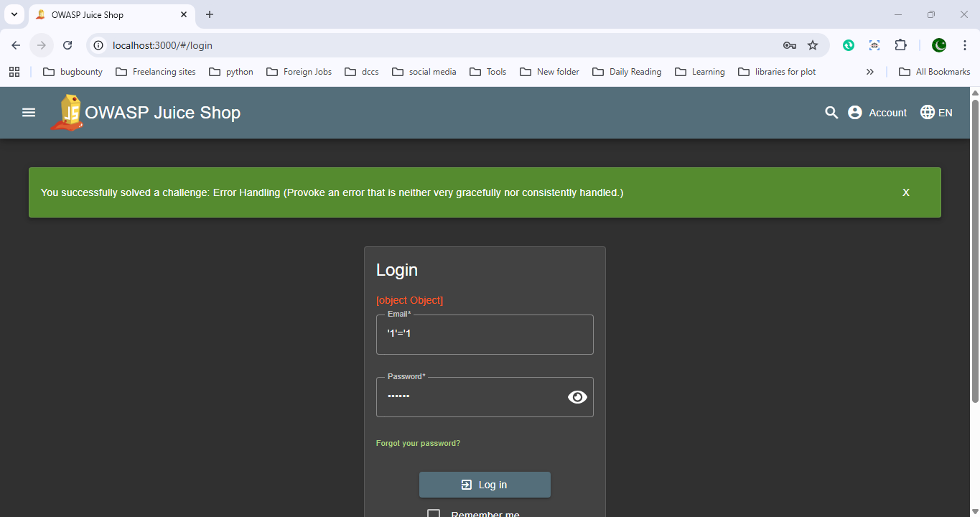

🔎 3.5 Cross-Site Scripting (XSS) Testing
Payload Tested:
<script>alert('XSS');</script>
Used in text input fields via browser developer tools.
Finding:
Application is vulnerable to XSS in certain input areas.
Impact:
- Session hijacking
- Cookie theft
- Malicious script execution
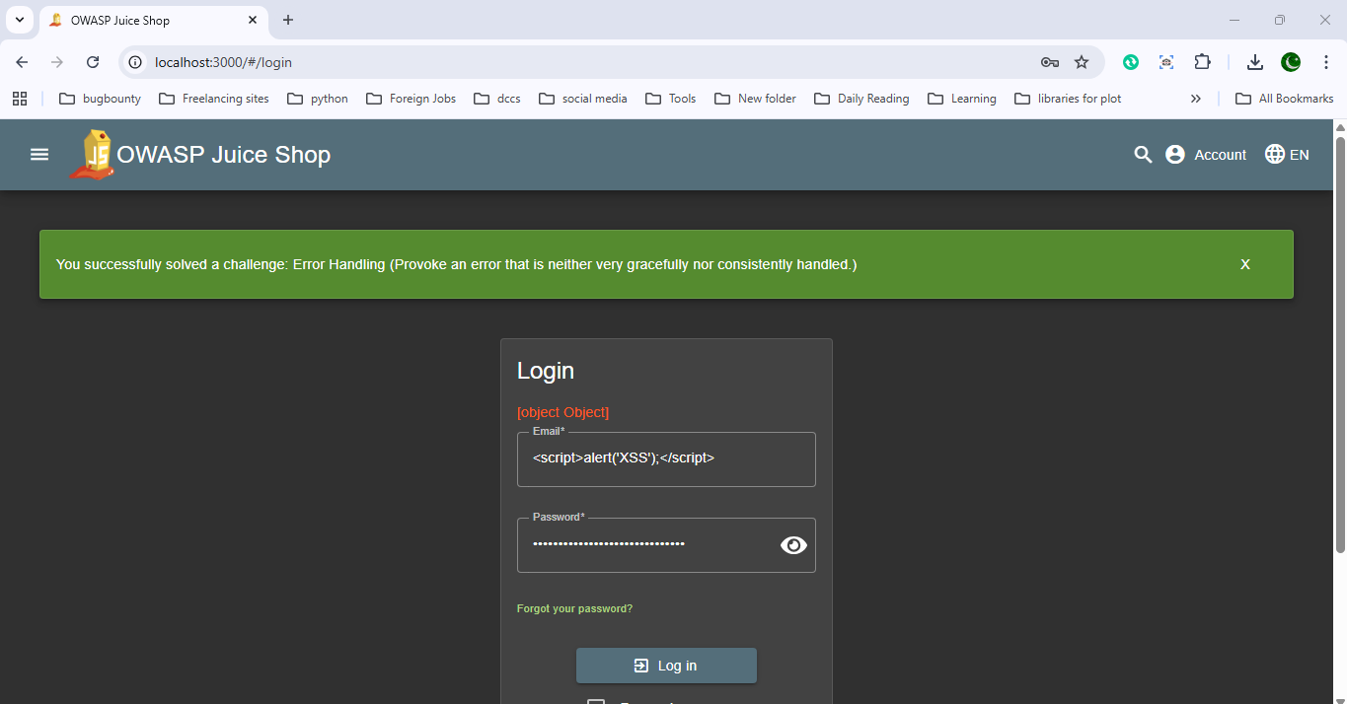
🔎 3.6 Cart Functionality
- Successfully added items to cart.
- Cart operations worked normally.
Finding:
No immediate security issue observed in cart operations.
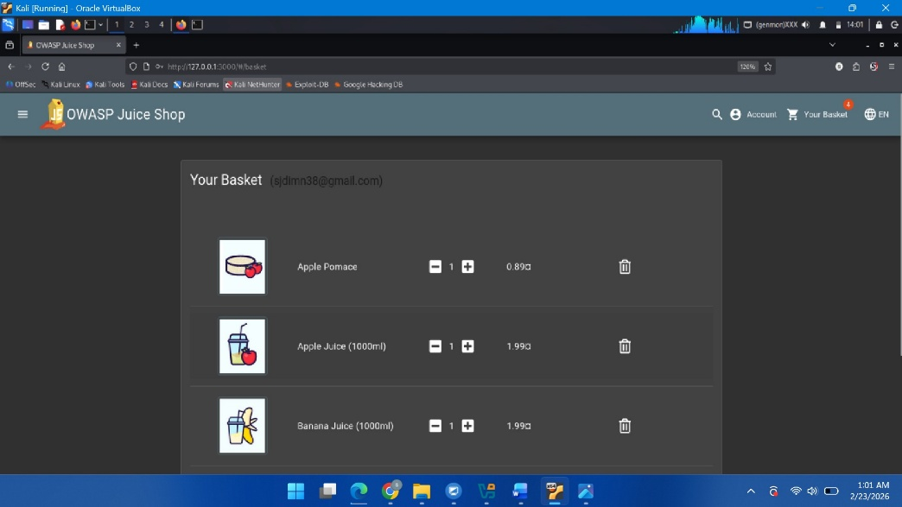
🔎 3.7 Profile Section Testing
- Accessed profile section successfully.
- Attempted to upload profile picture.
Result:
Upload failed (no database storage configured).
Finding:
⚠ File upload functionality incomplete.
Potential risk if improperly configured in production.


4️⃣ Identified Vulnerabilities Summary
Vulnerability | Severity | Description
SQL Injection | 🔴 High | Authentication bypass possible
Cross-Site Scripting (XSS) | 🔴 High | JavaScript injection possible
Improper Error Handling | 🟠 Medium | Internal logic exposure
Weak Misconfiguration | 🟠 Medium | Incomplete upload functionality
5️⃣ Areas of Improvement
✅ 1. Implement Prepared Statements
Use parameterized queries to prevent SQL Injection.
✅ 2. Sanitize User Input
Apply strict input validation and output encoding to prevent XSS.
✅ 3. Improve Error Handling
- Remove detailed error messages from frontend.
- Log errors securely on server-side.
✅ 4. Secure File Uploads
- Validate file type
- Store files securely
- Use authentication & access control
✅ 5. Implement Security Headers
- Content Security Policy (CSP)
- X-Frame-Options
- X-Content-Type-Options
6️⃣ Tools Used
- Browser Developer Tools
- Manual Testing
- SQL Injection Payloads
- XSS Test Scripts
7️⃣ Conclusion
The assessment of OWASP Juice Shop revealed multiple common web vulnerabilities including:
- SQL Injection
- Cross-Site Scripting (XSS)
- Improper Error Handling
These vulnerabilities demonstrate how insecure coding practices can lead to serious security risks.
The lab successfully helped in understanding:
- Web application attack surfaces
- Input validation weaknesses
- Authentication bypass techniques
- Secure coding importance
🎯 Final Remarks
This exercise provided hands-on exposure to real-world web application vulnerabilities and strengthened understanding of:
- OWASP Top 10 Risks
- Basic penetration testing
- Secure development practices

